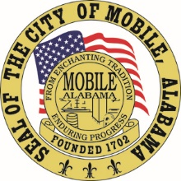

The City of Mobile, Alabama
Mobile City Planning Commission

Letter Of Decision

August 12, 2020

Clark, Gear, Latham & Associates
3901 Springhill Ave
Mobile, AL 36608

Re: 4350 and 4362 Government Boulevard
(Northwest corner of Government Boulevard and Polaris Drive).
Council District 4
SUB-001321-2020 (Subdivision) (Holdover)
Skyland Park Subdivision, Addition to
Number of Lots / Acres: 2 Lots / 1.6± Acres

Dear Applicant(s)/ Property Owner(s):

At its meeting on August 6, 2020, the Planning Commission considered the above referenced subdivision.

After discussion, the Planning Commission heldover the request to until the August 20th meeting, to allow the applicant to coordinate with staff regarding the setback requirements.

If you have any questions regarding this action, please call this office at 251-208-5895.

Sincerely,

MOBILE CITY PLANNING COMMISSION
Ms. Jennifer Denson, Secretary

By: ________________________________________
Margaret Pappas
Deputy Director of Planning and Zoning

cc:

