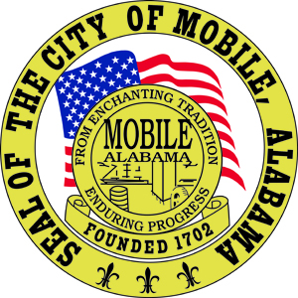

The City of Mobile, Alabama
Mobile City Planning Commission

Letter Of Decision

June 5, 2020

Ramshead LLC
12351 188 Hwy
Grand Bay, AL 36541

Re: 5536 Sermon Road West and 5660 & 5680 Sermon Road North
(Northeast corner of Sermon Road North and Willis-Sermon Connector and Southwest corner of Sermon Road West and Willis-Sermon Connector).
Council District 4
SUB-001172-2020
Collins Subdivision, First Addition, Resubdivision of Lots 10-12
Number of Lots / Acres: 2 Lots / 1.0± Acre
Engineer / Surveyor: Polysurveying Engineering-Land Surveying

Dear Applicant(s)/ Property Owner(s):

At its meeting on June 4, 2020, the Planning Commission considered the above referenced subdivision.

After discussion, the Planning Commission heldover the request until the August 6, 2020 meeting, at the request of the applicant.

If you have any questions regarding this action, please call this office at 251-208-5895.

Sincerely,

MOBILE CITY PLANNING COMMISSION
Ms. Jennifer Denson, Secretary

By: ________________________________________
Margaret Pappas
Deputy Director of Planning and Zoning

Cc: Polysurveying

