The City of Mobile, Alabama

Board of Zoning Adjustment

Letter Of Decision

September 24, 2020

The Fernbank Apartments, LLC
PO Box 850742
Mobile, AL. 36685

Re: #6347/6335/6243/5603
(Case #BOA-001364-2020)
The Fernbank Apartments, LLC
1400 Church Street
(Northwest corner of Church Street and Everett Street).
Council District 2

Dear Applicant(s) / Property owner(s):

On September 14, 2020, the Board of Zoning Adjustment considered your request for a Surfacing Variance to allow gravel surfacing for a parking lot in an R-1, Single-Family Residential District; the Zoning Ordinance requires all parking to be paved with asphalt, concrete, asphaltic concrete, or an approved alternative paving surface for parking lots in an R-1 Single Family Residential District.

After discussion, the Board determined the following Findings of Fact for Approval of the Surfacing Variance request:

- Approving the variance will not be contrary to the public interest in that the use would be consistent with the original architectural aesthetics of the property;
- Special conditions were illustrated such that the literal enforcement of the provisions of the chapter will result in an unnecessary hardship; and
- The spirit of the chapter shall be observed and substantial justice shall be done to the surrounding neighborhood by granting the variance because the use would be compatible to the site’s original development.

The approval is subject to the following conditions:

- completion of the Architectural Review Board review process with regards to the proposed gravel surfacing:
- compliance with Engineering comments (If the aggregate surfacing is approved for use the applicant will need to have the following conditions met: 1. Submit and receive a Land Disturbance Permit through Central Permitting for the proposed site development. 2. Aggregate surfacing will NOT be allowed within the public ROW. 3. Designated handicapped accessible spaces and routes must be paved (i.e. concrete, asphalt).);
- compliance with Traffic Engineering comments (If gravel surface is an acceptable use for this site, the gravel should not extend into the right of way. Required on-site parking, including ADA handicap spaces, should meet the minimum standards as defined in Section 64-6 of the City’s Zoning Ordinance.); and
- full compliance with all municipal codes and ordinances.

Any party aggrieved by this decision may, within fifteen days of the date of the decision, appeal to the Circuit Court of Mobile County by filing a written notice of appeal, specifying the decision from which the appeal is taken. Notice of the appeal, as well as a date stamped copy of the appeal filed in Circuit Court must be filed with this Board within the fifteen-day appeal period.

No permit, license or certification can be issued until the 15-day appeal period has expired and no appeal has been made. If a permit/license has not been obtained on or before March 14, 2021, the variance will expire and become null and void.

For additional assistance call (251) 208-5895.

Sincerely,

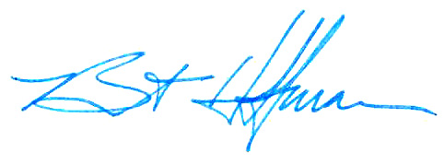
BOARD OF ZONING ADJUSTMENT

William Guess, Chairman

By: __________________________________________
Bert Hoffman
Principal Planner

cc: Joseph P. Vegliacich
Mark B. Hammond Architect

