The City of Mobile, Alabama

Board of Zoning Adjustment

Letter Of Decision

September 24, 2020

Shaun Small
SMALL PROPERTY LLC
5651 Three Notch Rd
Mobile AL 36619

Re: #6346
(Case #BOA-001363-2020)
Shaun Small
5651 Three Notch Road
(South side of Three Notch Road, 440’± West of Old Pascagoula Road).
Council District 4

Dear Applicant(s) / Property owner(s):

On September 14, 2020, the Board of Zoning Adjustment considered your request for a Off-Site Parking Variance to allow the use of temporary off-site parking in a B-3, Community Business District; the Zoning Ordinance requires all parking to be provided on-site in a B-3, Community Business District.

After discussion, the Board Heldover the request to the October 5, 2020 meeting, with revisions due by September 21st to allow the applicant time to provide the following information:

- Provision of a revised site plan illustrating the location and compliance of all proposed temporary parking spaces on abutting properties; and
- Provision of signed statements and verifiable ownership documents from abutting property owners permitting their property to be used for temporary parking associated with the subject property.

For additional assistance call (251) 208-5895.

Sincerely,

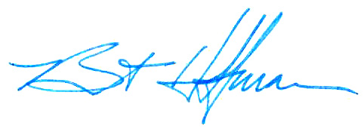
BOARD OF ZONING ADJUSTMENT

William Guess, Chairman

By: __________________________________________
Bert Hoffman
Principal Planner

