The City of Mobile, Alabama

Board of Zoning Adjustment

Letter Of Decision

September 24, 2020

CASEY PIPES
Post Office Box 2767
Mobile, AL 36652

Re: #6345/6093
(Case #BOA-001361-2020)
Temple Lodge LLC (Casey Pipes, Agent)
55 North Warren Street
(Northwest corner of St. Francis Street and North Warren Street, extending to the Southwest corner of St. Michael Street and North Warrant Street).
Council District 2

Dear Applicant(s) / Property owner(s):

On September 14, 2020, the Board of Zoning Adjustment considered your request for a Transparency Variance to allow reduced transparency in a T5.1, Mixed Use of Medium Intensity Sub-District of the Downtown Development District; the Zoning Ordinance requires a minimum 15% transparency for each floor of a building’s façade in a T5.1, Mixed Use of Medium Intensity Sub-District of the Downtown Development District.

After discussion, the Board determined the following Findings of Fact for Approval of the requests:

- Approving the variance will not be contrary to the public interest in that similar Transparency Variance requests in the vicinity have previously been approved by the Board;
- Special conditions were illustrated such that the literal enforcement of the provisions of the chapter will result in an unnecessary hardship, as privacy would be reduced and increased heat gain would occur; and
- The spirit of the chapter shall be observed and substantial justice shall be done to the surrounding neighborhood by granting the variance because the integrity of the proposed structure will be preserved.

The approval is subject to the following conditions:

- Full compliance with all other municipal codes and ordinances.

Any party aggrieved by this decision may, within fifteen days of the date of the decision, appeal to the Circuit Court of Mobile County by filing a written notice of appeal, specifying the decision from which the appeal is taken. Notice of the appeal, as well as a date stamped copy of the appeal filed in Circuit Court must be filed with this Board within the fifteen-day appeal period.

No permit, license or certification can be issued until the 15-day appeal period has expired and no appeal has been made. If a permit/license has not been obtained on or before March 14, 2021, the variance will expire and become null and void.

For additional assistance call (251) 208-5895.

Sincerely,

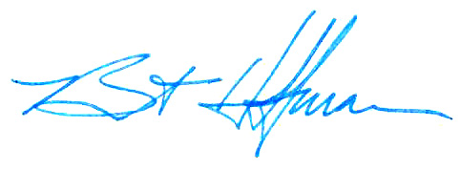
BOARD OF ZONING ADJUSTMENT

William Guess, Chairman

By: __________________________________________
Bert Hoffman
Principal Planner

cc: TEMPLE LODGE LLC

