The City of Mobile, Alabama

Board of Zoning Adjustment

Letter Of Decision

September 24, 2020

David Shumer
BARTON & SHUMER ENGINEERING, LLC
3213 MIDTOWN PARK S
MOBILE AL 36606

Re: #6344
(Case #BOA-001360-2020)
Gary Beasley II
741 Lakeside Drive West
(East side of Lakeside Drive West, 93’± North of Lakeside Drive South).
Council District 4

Dear Applicant(s) / Property owner(s):

On September 14, 2020, the Board of Zoning Adjustment considered your request for a Tree Planting, Front Landscape Area, Side Yard Setback, and Multiple Structures Variances to allow the construction of a second primary structure and connecting canopy on a single building site less than 5’ from a side property line with reduced tree and landscaping in a B-3, Community Business District; the Zoning Ordinance requires full compliance with tree and landscape area requirements, a minimum side yard width of 5’, and a separate building site for each structure other than an accessory structure in a B-3, Community Business District.

After discussion, the Board determined the following Findings of Fact for Approval of the Tree Planting, Front Landscape Area, Side Yard Setback, and Multiple Structures Variance requests:

- Approving the variances will not be contrary to the public interest in that the requests will be in keeping with the character of the surrounding area;
- Special conditions were illustrated such that the literal enforcement of the provisions of the chapter will result in an unnecessary hardship; and
- The spirit of the chapter shall be observed and substantial justice shall be done to the surrounding neighborhood by granting the variance because the use will not change and traffic within the right-of-way should not be adversely affected.

The approval is subject to the following conditions:

- Donation of 13 heritage trees to the Mobile Tree Commission Tree Bank;
- Obtaining of after-the-fact permits for the development; and
- Full compliance with all other municipal codes and ordinances.

Any party aggrieved by this decision may, within fifteen days of the date of the decision, appeal to the Circuit Court of Mobile County by filing a written notice of appeal, specifying the decision from which the appeal is taken. Notice of the appeal, as well as a date stamped copy of the appeal filed in Circuit Court must be filed with this Board within the fifteen-day appeal period.

No permit, license or certification can be issued until the 15-day appeal period has expired and no appeal has been made. If a permit/license has not been obtained on or before March 14, 2021, the variance will expire and become null and void.

For additional assistance call (251) 208-5895.

Sincerely,

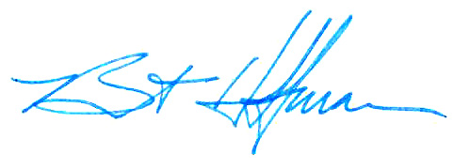
BOARD OF ZONING ADJUSTMENT

William Guess, Chairman

By: __________________________________________
Bert Hoffman
Principal Planner

cc: Gary Beasley

