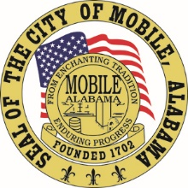

The City of Mobile, Alabama

Board of Zoning Adjustment

Letter Of Decision

September 24, 2020

WRICO Signs
3345 Halls Mill Rd
Mobile AL 36606

Re: #6343
(Case #BOA-001343-2020)
Wrico Signs (for Porsche of Mobile)
1533 East I-65 Service Road South
(East side of I-65, ¼ mile± South of Pleasant Valley Circle).
Council District 4

Dear Applicant(s) / Property owner(s):

On September 14, 2020, the Board of Zoning Adjustment considered your request for a Sign Variance to allow three (3) wall signs and one (1) freestanding sign on a single business site in a B-3, Community Business District; the Zoning Ordinance limits single business sites to a maximum of three (3) signs with no more than one (1) freestanding sign in a B-3, Community Business District.

After discussion, the Board determined the following Findings of Fact for Approval:

- Based on the fact that other automobile dealerships have been granted similar requests in the past, the variance will not be contrary to the public interest;
- This special condition (the affiliated manufacturer requires the signage package proposed) exists such that a literal enforcement of the provisions of the chapter will result in an unnecessary hardship; and
- The spirit of the chapter shall be observed and substantial justice shall be done to the applicant and the surrounding neighborhood by granting the variance in that the site will be afforded branding identification required by the affiliated vehicle manufacturer.

The Approval is subject to the following conditions:

- obtaining of the necessary sign permit for the proposed sign; and
- full compliance with all other municipal codes and ordinances.

Any party aggrieved by this decision may, within fifteen days of the date of the decision, appeal to the Circuit Court of Mobile County by filing a written notice of appeal, specifying the decision from which the appeal is taken. Notice of the appeal, as well as a date stamped copy of the appeal filed in Circuit Court must be filed with this Board within the fifteen-day appeal period.

No permit, license or certification can be issued until the 15-day appeal period has expired and no appeal has been made. If a permit/license has not been obtained on or before March 14, 2021, the variance will expire and become null and void.

For additional assistance call (251) 208-5895.

Sincerely,

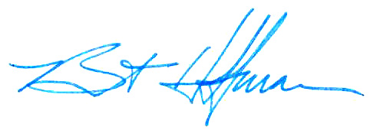
BOARD OF ZONING ADJUSTMENT

William Guess, Chairman

By: __________________________________________
Bert Hoffman
Principal Planner

