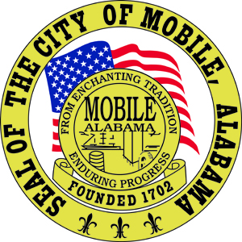

The City of Mobile, Alabama

Board of Zoning Adjustment

Letter Of Decision

May 5, 2020

Casey Pipes
150 Government St., Suite 2000
Mobile, AL 36602

Re: #6317
(Case #BOA-001228-2020)
Casey Pipes
1500 Government Street
(North side of Government Street, 300’+ East of South Catherine Street, extending to the East side of Catherine Street, 175’+ North of Government Street).
Council District 2

Dear Applicant(s) / Property owner(s):

On May 4, 2020, the Board of Zoning Adjustment considered your request for a Use Variance to allow a liquor store in an LB-2, Limited Neighborhood Business District; the Zoning Ordinance does not allow a liquor store in an LB-2, Limited Neighborhood Business District.

After discussion, the Board approved the Use Variance with the following findings of facts:

- The variance will not be contrary to the public interest;
- Special conditions exist such that a literal enforcement of the provisions of the chapter will result in unnecessary hardship; and
- The spirit of the chapter shall be observed and substantial justice done to the applicant and the surrounding neighborhood by granting the variance.
Any party aggrieved by this decision may, within fifteen days of the date of the decision, appeal to the Circuit Court of Mobile County by filing a written notice of appeal, specifying the decision from which the appeal is taken. Notice of the appeal, as well as a date stamped copy of the appeal filed in Circuit Court must be filed with this Board within the fifteen-day appeal period.

No permit, license or certification can be issued until the 15-day appeal period has expired and no appeal has been made. If a permit/license has not been obtained on or before November 5, 2020, the Use Variance will expire and become null and void. For additional assistance call (251) 208-5895.

Sincerely,

BOARD OF ZONING ADJUSTMENT

William Guess, Chairman

By: __________________________________________
Bert Hoffman
Principal Planner

