The City of Mobile, Alabama

Board of Zoning Adjustment

Letter Of Decision

September 24, 2020

Brian Metcalfe
METCALFE & COMPANY INC
5 Dauphin St, STE 101
Mobile AL 36602

Re: #6342
(Case #BOA-001337-2020)
Metcalfe & Company (Brian Metcalfe, Agent)
200 North Royal Street
(Block bounded by North Royal Street, State Street, North Water Street and St. Anthony Street).
Council District 2

Dear Applicant(s) / Property owner(s):

On September 14, 2020, the Board of Zoning Adjustment considered your request for a Building Material, Window Transparency and Fence Height Variances to allow a metal modular building with reduced window transparency, and a perimeter fence height of 10’ in a T-6 Sub-District of the Downtown Development District; the Zoning Ordinance prohibits metal exterior finishes on structures, requires a window transparency of at least 78%, and limits a perimeter fence height to a maximum of 8’ within a T-6 Sub-District of the Downtown Development District.

After discussion, the Board determined the following Findings of Fact for Approval:

- Approving the variance will not be contrary to the public interest because the proposed changes to the site are in keeping with the character of the existing development;
- Special conditions were illustrated such that a literal enforcement of the provisions of the chapter will result in an unnecessary hardship as the FBI has unique requirements related to security that other sites do not have; and
- The spirit of the chapter shall be observed, and substantial justice shall be done to the surrounding neighborhood by granting the variance.

The approval is subject to the following conditions:

- Obtain associated building permits; and
- Full compliance with all municipal codes and ordinances.

Any party aggrieved by this decision may, within fifteen days of the date of the decision, appeal to the Circuit Court of Mobile County by filing a written notice of appeal, specifying the decision from which the appeal is taken. Notice of the appeal, as well as a date stamped copy of the appeal filed in Circuit Court must be filed with this Board within the fifteen-day appeal period.

No permit, license or certification can be issued until the 15-day appeal period has expired and no appeal has been made. If a permit/license has not been obtained on or before March 14, 2021, the variance will expire and become null and void.

For additional assistance call (251) 208-5895.

Sincerely,

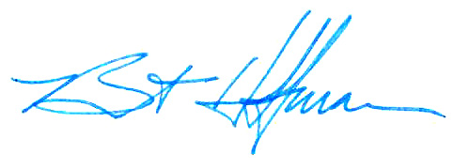
BOARD OF ZONING ADJUSTMENT

William Guess, Chairman

By: __________________________________________
Bert Hoffman
Principal Planner

cc: Castle USA

