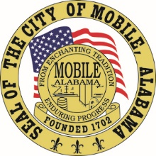

The City of Mobile, Alabama

Board of Zoning Adjustment

Letter Of Decision

September 24, 2020

Africatown Community Development Corporation
751 Edward Street
Mobile, AL 36610

Re: #6339/5800
(Case #BOA-001334-2020)
Africatown Community Development Corporation
400 Africatown Boulevard
(Northwest corner of Bay Bridge Road and Paper Mill Road, extending to Paper Mill Road Extension
Council District 2

Dear Applicant(s) / Property owner(s):

On September 14, 2020, the Board of Zoning Adjustment considered your request for a Use, Parking, Parking Surface, Buffering, Landscaping and Tree Planting, Setback and Signage Variances to allow a market in a split-zoned B-2, Neighborhood Business District and R-2, Two-Family Residential District with substandard parking, substandard parking surface, no residential buffering, no landscaping or tree plantings, reduced structure setbacks, and noncompliant signage; the Zoning Ordinance requires a B-3, Community Business District for a seasonal market, with compliant parking, parking surfacing, residential buffer, landscaping and tree plantings, with compliant structure setbacks and compliant signage.

After discussion, the motion to approve the request failed due to a lack of affirmative votes, thus the request was Denied.

You have until September 29th, or 15 days, to appeal the decision of the Board to the Circuit Court.

For additional assistance call (251) 208-5895.

Sincerely,

BOARD OF ZONING ADJUSTMENT

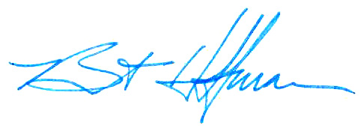
William Guess, Chairman

By: __________________________________________
Bert Hoffman
Principal Planner

cc: Chippewa Lakes LLC.

